Title or Task: |   

Description:

Files Required
Suitable for Classes: | AIT • Multimedia • Cert II IT • Cert II Bus
Area: | Technology & Enterprise
Teacher: | Mr Peter Faulks

Timeline

Date Due:
Task Brief: | In class lesson

Outcomes:

SOLUTIONS

See completed page
http://peterfaulks.net/Teaching/Student_Compendium/SC027_Negatives.htm
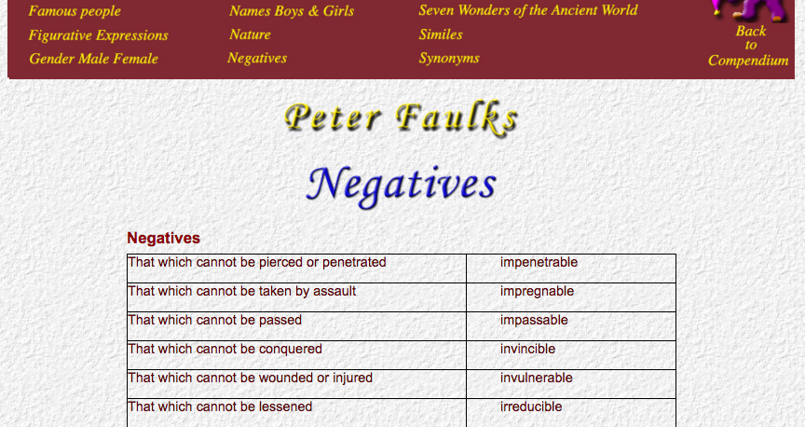

OPPOSITES
(Writing) that is easy to read | legible
Writing that is difficult to decipher | il-legible
Able to read | literate
Unable to read | il-literate
Fit for food | edible
Unfit for human consumption | in-edible
Fit to be chosen or selected | eligible
Not having the qualities of being chosen | in-eligible
Loud enough to be heard | audible
Not distinct enough to be heard | in-audible
Born of married parents | legitimate
Born of unmarried parents | il-legitimate
To remove from one country to another | migrate
One who leaves his country to settle in another | emigrant
One who comes into a foreign country to settle there | immigrant
To send back a person to his own country | repatriate
To banish from one's country | expatriate
Love of one's country | patriotism
Goods brought into a country | imports
Goods carried out of a country | exports
A list or table of duties payable on exports or imports | tariff
A list of goods despatched with quantity and price to the purchaser | invoice
One to whom goods are despatched | consignee

Negatives
migrate
Nemigrant
Negatives
That which cannot be pierced or penetrated | impenetrable
That which cannot be taken by assault | impregnable
That which cannot be passed | impassable
That which cannot be conquered | invincible
That which cannot be wounded or injured | invulnerable
That which cannot be lessened | irreducible
That which cannot be repaired or remedied | irreparable
That which cannot be made good in case of loss | irreplaceable
That which cannot be imitated | inimitable
That which cannot be rubbed out or blotted out | ineffaceable, indelible
Incapable of making errors | infallible
Incapable of being destroyed | indestructible
 | impenetrable
Incapable of being redeemed from evil, i.e. beyond correction | incorrigible

repatriate
expatriate
patriotism
imports
exports

migrate
emigrant
immigrant
repatriate
expatriate
patriotism
imports
exports
tarifrhizome
vertebrates
invertebrates
kernel



